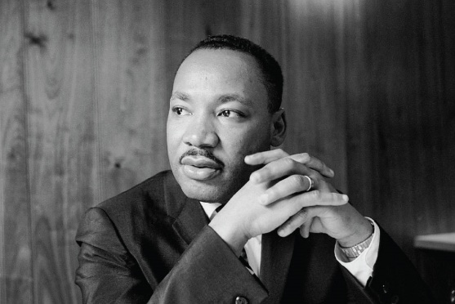
Martin Luther King Jr was an American campaigner for the fair and equal treatment of all people and an end to racial discrimination. A brilliant and brave man and a brilliant speaker, he was the youngest-ever person to win the Nobel Peace Prize. He was born 15th January 1929 and he died 4th April 1968.
During Black History Month, Wren class learned about this great man. We talked about how he dreamed that things could get better and he helped people to make changes that have made things better for all of us today. We talked about our own dreams and aspirations for the future and what we would like to do when we are older. The jobs that people do and how they we can help each other.
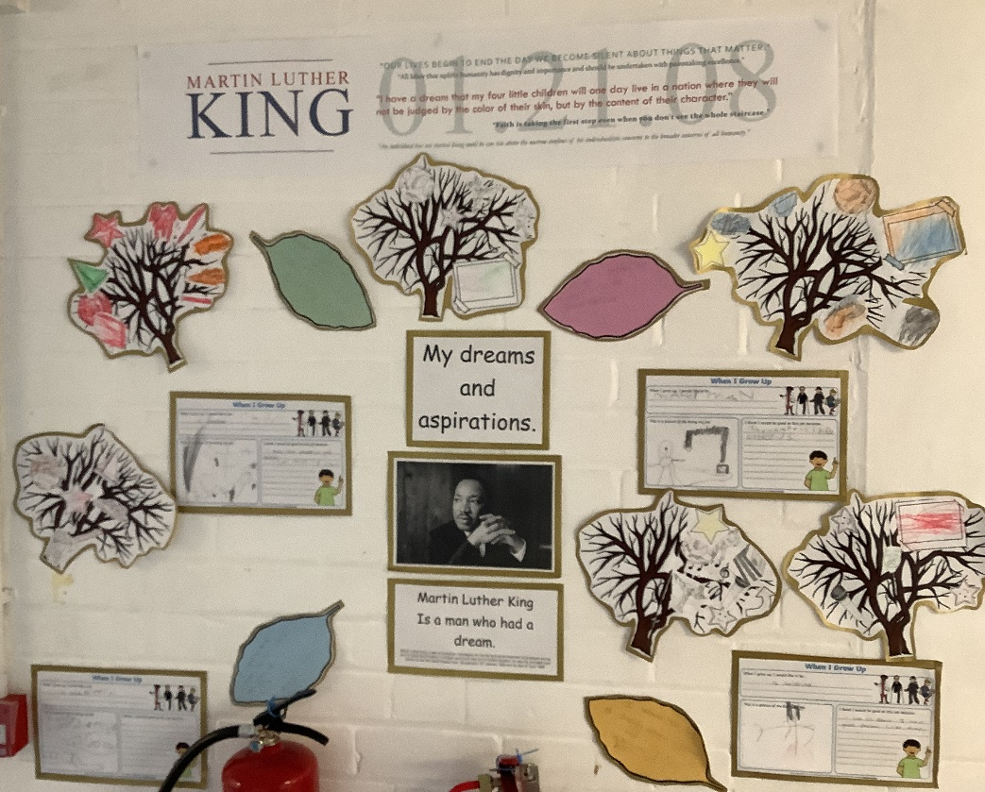
Our work on display.
We also learned a song about Martin Luther King Jr.
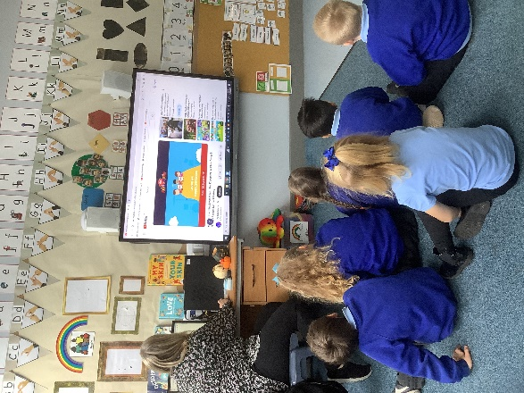

We continued to explore the theme of dreams in our yoga and relaxation sessions this month.
