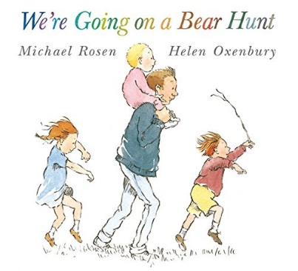
Robins Autumn 1 Medium
Term Plans 2021

Literacy and Communication

- Sign, listen and respond to Bear Hunt Sensory Story – See Session plan for differentiation/activities
- Engaging with a story book, Tuesday focused activities - See individual plans

ELKLAN questioning
Singing and signing
Individual SALT programmes
Social Skills

ICT programmes - beep beep, HelpKidzLearn, Lightbox
FMS, mark making, OT programmes
Cause and effect

Learning objectives:

- To join in with a group activity
- To develop pre writing skills
- To show interest in their own lives
- To show interest in the lives of people who are familiar to them
- To trace their name -OJ

Cognition and Numeracy

- Thursday Focused activities - See individual plan
- Bear Hunt Sensory Story – See session plan for differentiation/activities
- Tuesday Cookery - See session plan for differentiation/activities

Construction, jigsaw, playdoh, sand and water, shape sorters, cause and effect toys
Exploring shape and number through sensory play

Learning objectives:

- To show an enjoyment of number rhymes and songs
- To join in with a group activity
- To complete workstation tasks supported by an adult

Fine and Gross Motor Skills / Physical Activity
·
- Monday, Wednesday, Friday Sensory Room Sessions
- Monday and Thursday Sensory Circuit - See individual plan
- Daily access to Robins sensory room
- Friday PE sessions in the hall - See session plan for differentiation/activities
- Friday Forest School
- Daily access to soft play sessions
- Daily access to outside play
Occupational Therapy - See individual OT plans
Fine/Gross motor activities – See activity list
Access to school swings

Learning objectives:

- To explore new environments
- To walk around the scool without support
- To walk around the school with support
- To develop my fine motor skills
- To make controlled movements
- To jump and land on two feet
- To regulate by body

PHSE

- Bear Hunt Sensory Story – See session plan for differentiation/activities
- Monday and Thursday Self-Awareness Session - See session plan for differentiation/activities
- Sensory Room - See session plan for differentiation/activities

Daily input through routines - toilet skills, putting shoes on/off, washing hands, using a knife and fork, communicating with others to get toys/ food, putting coat on/off, hanging coat up, following instructions
See individual Care Plans
Social Skills - playing alongside and sharing equipment, eye contact, reciprocal play, taking turns, 1:1 intensive interaction sessions
Daily input through circle time & hello: responding to name; recognising peers; identifying themselves in a photo/ reflection; days of the week; turn taking.
Daily hygiene - brushing teeth, washing hands/face
Learning objectives:

- To understand the need to stay clean
- To wipe my own face
- To help with handwashing
- To brush my teeth with support
- To begin to use cutlery to eat with

Creative and Expressive Arts

- Wednesday Focused activities - See individual plan
- Bear Hunt Sensory Story – See session plan for differentiation/activities
- Monday and Thursday Self-Awareness Session - See session plan for differentiation/activities
- Sensory Room - See session plan for differentiation/activities

Singing and signing
Songs on the whiteboard to coincide with our topic
Jelly and Fish, Ice and Polar Bears, Pasta Pictures, Balloons, Cotton Balls with Paint
Balloons and Dinosaurs, Ice Boats, Caterpillars, Cress tights, compost, cress seeds
Foot Spa, Puffy Paint, Feather Paining, Cookery, Rubbery Gloop, Spaghetti Play

Celebration Activities

Learning objectives:

- To explore musical instruments
- To follow directions
- To repeat actions that have an effect
- To explore colours through printing, painting and mark making
- To be interested in the effect of making movements that leave marks
- To select appropriate tools

Knowledge and Understanding of the World

- Bear Hunt Sensory Story – See session plan for differentiation/activities
- Monday and Thursday Self-Awareness Session - See session plan for differentiation/activities

Investigation of through sensory play, role play, dressing up, cooking

Learning objectives:

- To enjoy the outside environment
- To explore an outdoor environment
- To go on a nature hunt

