Evidencing the Impact of Primary PE and Sport Premium 2019/20
Guidance and Evidence for Ashgate School
Department for Education Vision for the Primary PE and Sport Premium
ALL pupils leaving primary school physically literate and with the knowledge, skills and motivation necessary to equip them for a healthy, active lifestyle and lifelong participation in physical activity and sport.

The funding has been provided to ensure impact against the following OBJECTIVE:
To achieve self-sustaining improvement in the quality of PE and sport in primary schools. It is important to emphasise that the focus of spending must lead to long lasting impact against the vision (above) that will live on well beyond the Primary PE and Sport Premium funding.
It is expected that schools will see an improvement against the following 5 key indicators:
- the engagement of all pupils in regular physical activity – kick-starting healthy active lifestyles
- the profile of PE and sport being raised across the school as a tool for whole school improvement
- increased confidence, knowledge and skills of all staff in teaching PE and sport
- broader experience of a range of sports and activities offered to all pupils
- increased participation in competitive sport
Under the new Inspection Framework, Ofsted inspectors will assess how effectively leaders use the Primary PE and Sport Premium and measure its impact on outcomes for pupils, and how effectively governors hold them to account for this. Improvements should enhance, rather than maintain existing provision. For example, where schools are using their funding to employ specialist coaches, these should be deployed alongside class teachers rather than displacing them, in order for their impact to be sustainable and to enable the upskilling of existing teachers.

Primary Physical Education and Sport Premium planning and actions should show how use of funding contributes to this vision through identified school priorities which can be measured through reference to key outcome indicators. It is important that the main drivers for improvement are those identified by the school through their self-review. Each school should aim to achieve the following objective:
Objective: To achieve self-sustaining improvement in the quality of PE and sport in primary schools.
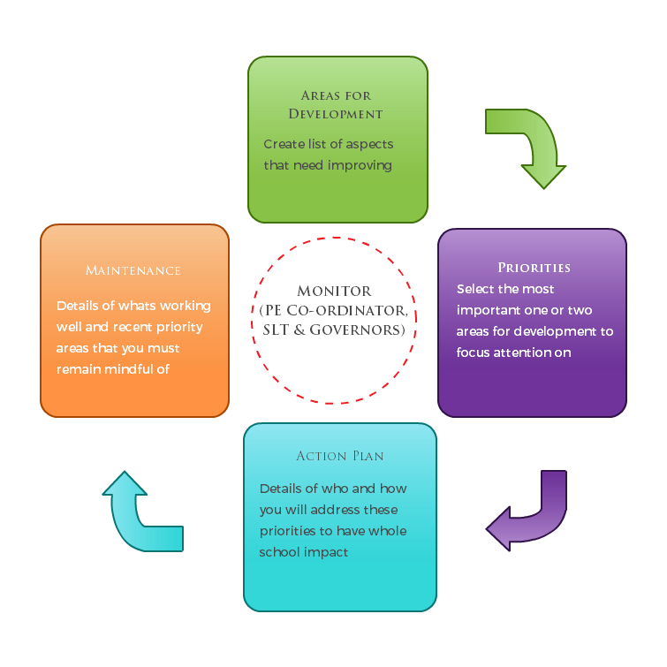
This model of thought supports our planning of spending and priorities for the development of PE and sport in school.

Department for Education Guidance on How to use the Primary PE and Sport Premium
Schools must use the funding to make additional and sustainable improvements to the quality of PE and sport they offer. This means that you should use the premium to:
- develop or add to the PE and sport activities that your school already offers
- make improvements now that will benefit pupils joining the school in future years For example, you can use your funding to:
- hire qualified sports coaches to work with teachers
- provide existing staff with training or resources to help them teach PE and sport more effectively
- introduce new sports or activities and encourage more pupils to take up sport
- support and involve the least active children by running or extending school sports clubs, holiday clubs and Change4Life clubs
- run sport competitions
- increase pupils’ participation in the School Games
- run sports activities with other schools You should not use your funding to:
- employ coaches or specialist teachers to cover planning preparation and assessment (PPA) arrangements - these should come out of your core staffing budgets
- teach the minimum requirements of the national curriculum – including those specified for swimming.

Reflection: What have we achieved and where next?

Key priorities to date | Key achievements/What worked well: | Key Learning/What will change next year:
All children to access swimming sessions to develop water confidence & swimming techniques as appropriate to their level of development. Two additional weekly swimming sessions have continued to bepurchased to increase the number of children who can access swimming. | All classes have been able to access at least one term of swimming in a setting appropriate to them. We have had access to our own hydrotherapy pool, Wythenshawe Forum for lessons and water play/confidence building sessions and Manchester Aquatics Splash Pool for our sensory learners.  Children have developed swimming water confidence skills as appropriate to their level of development.  Several of our children have achieved their 25m certificate and many of our children who were previously scared of water are now swimming confidently with armbands. | We want to maintain these swimming opportunities for all our pupils next year so that by the time all our children leave us in Year 6 they have either learnt to swim or are confident in water.  Where appropriate, children who have only accessed sessions of hydrotherapy will have the opportunity to visit off site sessions of swimming at either the Forum.
To ensure all year 6 children access Ghyll head to give a broader experience on a range of physical activities and build confidence to continue regular experience when they leave Ashgate. | We were able to fund part of the Ghyll head trip allowing more children to access these experiences. Due to COVID 19 this was cancelled. | We would like to continue to offer children an opportunity to participate in a broader experience in Physical activity and help build their confidence to take part.
For as many pupils to access high quality P.E lessons increasing the profile of P.E and sport throughout school.  To develop staff confidence, knowledge and understanding to deliver high quality P.E lessons. | We have maintained and established a good relationship with a specialist coach. He has been working with staff to develop their delivery of P.E. This has ensured more children are engaged in physical activity.  We have worked with the coach to develop a school curriculum in Physical activity. | More children next year to be engaged in high quality P.E sessions. The specialist coach to continue to work along staff continuing to develop staff delivery of P.E.  Specialist coach to give whole school training.  Specialist sport coach to develop  inter- competition.
To increased confidence, knowledge, and skills of all staff in teaching PE and sport to ensure the majority of pupils to access high quality P.E lessons and sports. | Both P.E leads will access training to develop their knowledge and understanding of P.E. This has enabled them to create a Physical Activity Curriculum within school with the support of the P.E Specialist. | The Physical Activity curriculum will be finalised and all staff will be able to use this to support them with high quality P.E lessons which is meaningful to their children.
For as many children as possible to access competitive sporting events both with children from within the school and against other schools. | Children have attended the multi sports day which competed with other schools. We have a football team who have represented the school in this year Manchester City’s football tournament. We have had a team enter a bocci competition. All classes participate in sports day that was meaningful to them. We had a coach in running competitive sports providing a safe environment for them to build their confidence. | The children who have attended these events have felt a real sense of achievement, as have their parents. We would like to ensure next year that we are able to extend this competitive experience to more children with a range of different sports.  We would like to continue to run sports day.  Specialist sport coach to develop inter- competition.
For all children to access outside activities including Forest school in all-weathers to increase the engagement in regular physical activity. | More classes were accessing Forest schools and the outside learning environment as they had the appropriate clothing. Children have been able to build their confidence and engage in regular activity in the outdoors. This has even included trips to the park. | To continue to encourage children to engage in regular exercise in the outdoors with the appropriate clothing.
To ensure all children access regular physical activity, broaden the experience of sports and activities as well participate In competitive sport safely with the correct amount of staff support. | More children where able to access rebound therapy, swimming off site and in the school hydro. Classes where able to participate in competitions again on and off site ensuring there was enough support to ensure all children where safe. | To continue to provide extra support to ensure all children can access a variety of physical experiences safely.

Vision: ALL pupils leaving primary school physically literate and with the knowledge, skills and motivation necessary to equip them for a healthy, active lifestyle and lifelong participation in physical activity and sport.
Objective: To achieve self-sustaining improvement in the quality of PE and sport in primary schools against 5 key indicators:
- the engagement of all pupils in regular physical activity – kick-starting healthy active lifestyles
- the profile of PE and sport being raised across the school as a tool for whole school improvement
- increased confidence, knowledge and skills of all staff in teaching PE and sport
- broader experience of a range of sports and activities offered to all pupils
- increased participation in competitive sport
Reflection: What have we achieved and where next?

Academic Year:  2019/2020 |  | Total fund allocated: £ 17,038
Primary PE &  Sport Premium  Key Outcome  Indicator | School Focus/ planned Impact on pupils | Actions to Achieve | Planned Funding | Actual Funding | Evidence | Actual Impact  (following  Review)on pupils | Sustainability/ Next Steps
The engagement of all pupils in regular physical activity – kick-starting healthy active lifestyles | For all children to access swimming sessions to develop their swimming ability and water confidence according to their stage of development | To pay for additional sessions of swimming at the Forum & Aquatics Centre and to pay for additional staff to support the sessions as required. | £426.09 | £187.50  (cost of swimming sessions and additional support for pupils in the water) | Timetabling of swimming sessions for all children. Improvement in water confidence and swimming skills. See individual children’s records/My Life at Ashgate files to measure progress and outcomes. | Most children in the school have had access to swimming or hydrotherapy sessions as appropriate. Some children have achieved their 25m certificate and many are now swimming independently using arm bands/floats etc. COVID-19 affected children’s access to swimming as the pools were closed. | To look at the individual progress of pupils and ensure that the right swimming experiences are planned for them next year. Eg moving children from hydro pool to Aquatics Centre swim.
Broader experience of a range of sports and activities offered to all pupils | For as many of our year 6 pupils as possible to access an outdoor and adventurous residential trip | To organise a booking at Ghyll Head that will cater for the needs of our children ensuring that all children have access to an appropriate, quality outdoor activity experience, | £5000 cost of trip plus any necessary subsidy for staffing of trip so that as many children can attend as possible. | £5000 | Evidence of the number of children who have accessed the trip and the types of activity they have experienced. See individual children’s records/My Life at Ashgate files to measure | Due to COVID-19 19 this trip was cancelled, but was already paid for. | To review the previous year’s trip and assess whether Ghyll Head has met the needs of our children and offered them the relevant and appropriate challenge. To continue to develop our own outdoor activity in the forest school area.
The profile of PE and sport being raised across the school as a tool for whole school improvement  Increased confidence, knowledge and skills of all staff in teaching PE and sport | For as many pupils to access high quality P.E lessons increasing the profile of P.E and sport throughout school. | To pay for an experienced coach to deliver P.E lesson and work with staff to develop their knowledge and understanding of how to deliver Quality P.E lessons. To support the development of the school Physical Activity curriculum. For all classes to access P.E and sport adapting to the children needs.  To deliver whole school staff training program. | £5200 | £4620 | More children engaging in high quality P.E sessions. Staff are beginning to develop their confidence in delivering P.E lesson. They are implementing the experienced professional’s suggestions.  Ashgate Physical Activity curriculum has been drafted and it is in the finalised stages.  Due to COVID 19 this has been delayed. | More children are accessing and enjoying high quality P.E lessons and engaging with activities and staff during this time. Less behaviour issues during P.E as children are more engaged with appropriate activities.  Due to COVID 19 the training had to be postponed. | To continue to use the coach ensure that staff develop their knowledge and understanding of how to provide high quality P.E lessons in school.  To deliver whole school training to increase staff confidence, knowledge, and skills.
To increased confidence, knowledge, and skills of all staff in teaching PE and sport | For the majority of pupils to access high quality P.E lessons and sports. | P.E leads to research curriculums to develop a curriculum for children in school and train school staff on how to deliver the curriculum. P.E leads to go on Creative Development training. | £290.00 | £290.00 | Ashgate Physical Activity Curriculum  has begun to be written and it is in the process of being finalised. Staff can access this to help deliver their P.E lessons. | All children to have access to a high quality P.E lessons, which will meets their needs. Children enjoy P.E and sports and have opportunities to develop their fitness and interest in sport. | To finalise the school physical activity curriculum and train staff to use it.
To have increased participation in competitive sport | For children to join in competitive sport | To Join Manchester P.E association and Manchester Active to provide more opportunities to participate in competitive sports.  To participate in competitions with other schools.  Pay for addition staffing and transport to ensure safety of all. | £2130.30 | £2130.30 | More children have been engaged in competitive sport. Children’s ability to participate in sport has increased.  This was impacted on by Covid as competitions and events were cancelled | Children being active and enjoying competitive sport including learning to work as a team.  Children have competed in different competitions against other schools uo until March 2020 | To continue to ensure that children have positive and meaningful opportunities to engage in competitive sport and look at how this may have to be adapted in light of Covid.
The engagement of all pupils in regular physical activity – kick-starting healthy | For all children to access outside activities including Forest school in all weather. | To provided waterproof suits for most children in school. | £154.48 | £154.48 | Classes are timetabled to use the forest school ensuring children are all accessing outdoor and adventurous activity. | The use of the forest has developed, particularly with increased outdoor learning due to Covid. Staff have used their time to research, purchase and make resources for the forest eg; mud kitchens. | To continue to develop the forest school area and its use.  To look at the curriculum and see how it can be adapted for increased outdoor physical activity.
the engagement of all pupils in regular physical activity – kick-starting healthy active lifestyles  broader experience of a range of sports and activities offered to all pupils  increased participation in competitive sport | For all children to access regular activity through swimming off site, Hydro, rebound, off-site competitions, fun days and Sports days gaining a wider experiences of activities and sport. Children will enjoy physical activity and want to participate engaging them more. | To pay for extra staffing to allow classes and children to access all Physical activities safely ensuring the children get the maximum experiences and develop there physical activity skills and develop confidence in the activity in a safe environment. | £2895.19 | £2795.19 | Increased children access a wider range of Physical activity and competitive sports.  Classes have attended off site sports days, football tournaments and boccia tournaments. More classes accessing swimming and children develop their skills and confidence.  More classes accessing rebound therapy allowing to children access to regular physical activity | While classes were timetabled in 2019-20 to engage and participate in activities, some of these were prevented due to Covid. Football matches and swimming galas were attended up until March 2020. | To continue to ensure that children have positive and meaningful opportunities to engage in competitive sport and look at how this may have to be adapted in light of Covid.
Other money from sports premium has been used to ensure that high quality sports provision is accessible for all children. This included £941.94 towards new equipment to support the teaching of physical activity in the school.

