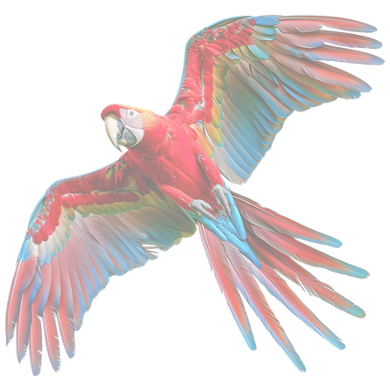Hello, and welcome to the new academic year. We hope you all had a lovely Summer break. We are all so excited to start the year with you and your child.

**Macaws autumn newsletter 2025**

The Macaws class consists of 10 unique and beautifully spirited children, seven boys and three girls.

The class team are: Gem, Emma, Joe, Laura and Louise (Monday and Tuesday).

We are all dedicated to helping your child grow in confidence and develop in all aspects of the school curriculum.

In the Macaws class we promote independence, individuality, kindness, friendship and communication through a total communication approach.

*Our class ethos values full collaboration with parents and carers. Our classroom door is always open. We invite you to be a part of your child's school environment and learning.*

**Throughout the autumn term we will be learning:**

How to keep ourselves safe in the local and wider community. This involves road safety whilst walking to ASDA to buy cookery ingredients, trips to the park and community walks.

**KUW –** people who help us in the community. A focus on doctors, nurses and paramedics

**Religious Education** – To recognise the qualities of some religious people within stories - kindness/bravery

**Art** – Drawing and sculpture. A focus on LS Lowry

**PH-RSE** – Kindness, respecting others, individuality, boundaries, keeping ourselves and others safe.

**D&T (Cookery)** – During the autumn term we will be making a selection of healthy meals including: Curries, soups, sandwiches and tray bakes.

**Maths** – Addition, subtraction and 3D shapes

**Home/school communication**

This is a very important aspect in your child’s learning. Thank you all for joining Class Dojo. You can message us privately or write a message to share updates or news on the class chat.

We value your input and communication.

Alternatively, you can phone the school on 0161 3595322 and ask to speak to Gem or a member of the Macaws class team. Between 8.30 and 8:30 or from 15.00 to 16.00 are preferred times. However, you can always speak to a member of the office team and leave a message, we will ensure to call you back.

You can also email Gem at:

g.yabsley@ashgate.manchester.sch.uk

**Contribution**

A voluntary contribution of £1 a week to support the cost of buying cookery ingredients would be greatly appreciated.

Thank you for your continuous support.

*Gem and the Macaws team.*